Learn.AI - LEARN the way it’s meant to be.

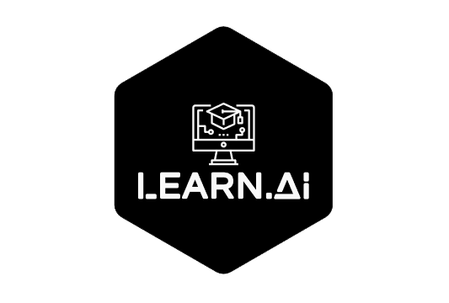

## Sri Manakula Vinayagar Engineering College, Puducherry

## Department of Computer Science and Engineering

## Team Members

Eathindhar. M [eathindhar@gmail.com](mailto:eathindhar@gmail.com) 8122652734

Gautham. A [gauthamarunachalam1998@gmail.com](mailto:gauthamarunachalam1998@gmail.com) 9789403377

Dinesh. V [dzieecorp.ceo@gmail.com](mailto:dzieecorp.ceo@gmail.com) 6380043316

Subramania Bharathy [bharathysubu98@gmail.com](mailto:bharathysubu98@gmail.com) 9489478543

## Team Mentors

Dr J.Madhusudanan,

Associate Professor,

Department of Computer Science and Engineering,

Sri Manakula Vinayagar Engineering College,

Puducherry.  
[9003739274](tel:(900)%20373-9274) [contactmadhu@gmail.com](mailto:contactmadhu@gmail.com)

Contents

[1. Introduction 3](#_Toc423978774)

[1.1. Problem Statement 3](#_Toc423978775)

[1.2. Current Issues / Constraints 3](#_Toc423978776)

[1.3. Future Process Flow due to this Solution 3](#_Toc423978777)

[1.4. Additional Features 3](#_Toc423978778)

[2. Solution Overview and Approach 4](#_Toc423978779)

[2.1. High Level Architecture Diagram 4](#_Toc423978780)

[2.2. Technical Stack 4](#_Toc423978781)

[2.3. Non Functional Coverage 4](#_Toc423978782)

[2.4. Implementation Architecture 4](#_Toc423978783)

[3. Delivery Plan 5](#_Toc423978784)

[Appendix – A 6](#_Toc423978786)

# Introduction

Education is the most important and foremost sector which needs a major updating to be done. We believe this because the more the students are enlightened the better doctors, engineers and teachers we get. Current AI systems are focused on scientific studies and in commercial markets. We say AI needs to be introduced to students in a far earlier time period. Here is where our Chatbot Learn.AI comes to play. We are introducing a Chatbot to interact with students make them learn their lessons in a fun way through the concept of Gamification!

Technology faces new boundaries and challenges every day. We have to find new ways to teach our budding innovators, it is our duty to do so. The objective of our work is to create a teaching model which can interact with the students to teach them their concepts in a far more fun way.

Who said History lessons are boring? Worry no more. Here is a fun way to learn them. The teaching methods used in schools are outdated. Even though there are modules which consists of 3D or 2D animated videos, it is not Interactive. Our Solution is based on

“Tell me and I forget.

Teach me and I remember.

Involve me and I learn. “

-Benjamin Franklin

## Problem Statement

As we move towards the Digital age, the Traditional Textbook method of Teaching is not sufficient. And so is taking notes, during class hours. Students can learn about historic events and personalities in a more fun way through a conversation rather than the traditional reading. This is helps them to retain information more easily. Because the student is more involved by this method. Our App Learn.AI gives notifications on important dates as a flashcards to help them prepare for their exams in a more stress-free way. Students need not by heart large volumes of text for their exams here after.

## Current Issues / Constraints

## Current Systems:

The Chatbot Systems used in Education are mostly for Student feedback systems etc. These are not implemented in classrooms. Currently Chatbots are mainly used in chat applications, in Private Virtual assistants and in stores, hotel or flight bookings. In Education, Chatbots are used for taking surveys, assisting students with forms and feedbacks.

## Limitations:

This could be achieved only if there is any recorded data about the person and his work, else the model will be useless. Large amount of data on a particular person is required to build a reliable system. Collecting these information will be a huge task. And Machines are sometimes prone to errors and a few queries cannot be answered or wrong information might be conveyed to the students, this needs to be checked by the staff periodically.

## Future Process Flow due to this Solution:

* Use of cloud technologies like Amazon Web services and DialogFlow will force the Educationist to provide updated content. Which will help the students very much.
* Interactive Teaching methodology will invite more students to attend classes willingly.
* Interest in learning among students will increase drastically, which is more needed in this competitive world.
* Students can be more equipped with technology which ensures their growth in a productive way.

## Additional Features

## Inclusion of new models:

The user can request for the inclusion of a new personality, wherein once sufficient datasets have been collected a Chatbot for that person can also be made.

## Extended Google Search:

The user can make a google search based on the information conveyed through the conversation with the touch of a button.

## Starring Conversations:

The key points of the conversations can be starred and stored separately, in order to access them later while in a hurry.

## Forum:

A group of students in the same class can post useful links and the staff can give announcements via this portal.

## External Sharing:

The information obtained through this conversation can be converted into a short note and this can be shared through external applications too.

## PDF Generation:

The entire conversation can be converted into a pdf file which provides a detailed notes about the person.

## Voice Assistant:

The user can speak to the Chatbot rather than typing and the Chatbot can reply by text as well as speak to the user.

## Subject Quiz:

At the end of the module, the user can take up a quiz to test his level of knowledge about that person.

## Alert Notifications:

The user will get notifications on important dates such as the birth dates of the personality, the day they made history etc. to help them remember better.

# Solution Overview and Approach

## Bringing the Dead back from the grave.

Our idea is to bring the dead back to life to teach the students, seems impossible? No it is not! Here is where Artificial intelligence plays its role. A Chat-Bot which is trained on a person’s audio and text speeches can be used to interact with students to teach them their invention. For example. Consider Albert Einstein, all his speeches in the form of text and audio files can be given to the Chat-Bot in order to train it to speak in the way he used to speak. And it can also be trained with queries that are to be answered. This Chat-Bot can interact with the Students to give them a unique experience which they will never forget in their life. A Contextual Chatbot built using TensorFlow is used!

## Bringing Letters to Motion.

Having a Chat-Bot would be a simple text based solution. To take Teaching to a whole new level, a 3D model of Albert Einstein can be developed and giving it the animations which pertains to him alone as a one of the few characteristics, can bring him back to life(Not exactly though). This 3D model of Einstein will behave like Einstein with his unique speech style, his voice and sentence formations, can give the students a more insight to what his life and his way of living was like. To render these models Unity and Blender can be used to animate these objects.

## Future of this Model and Usage:

Education will be revolutionized by this interactive model. This AI could also be used in training, students and industry people by giving them many queries, etc. Moreover, If provided with the support we believe that we can implement this Using **Augmented Reality** wherein, the object is rendered in real time, which will be more fun to learn and provides the user with a unique experience.

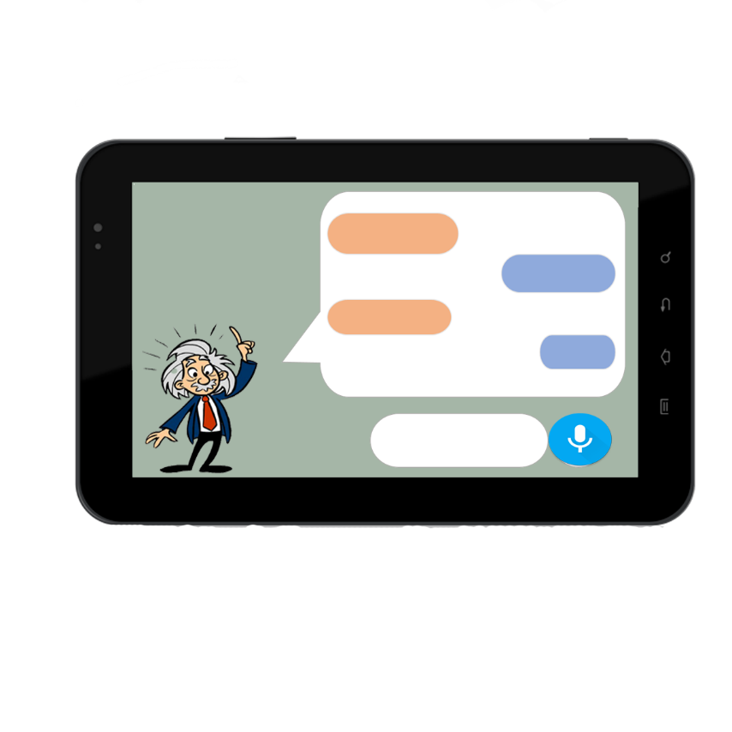

## High Level Architecture Diagram

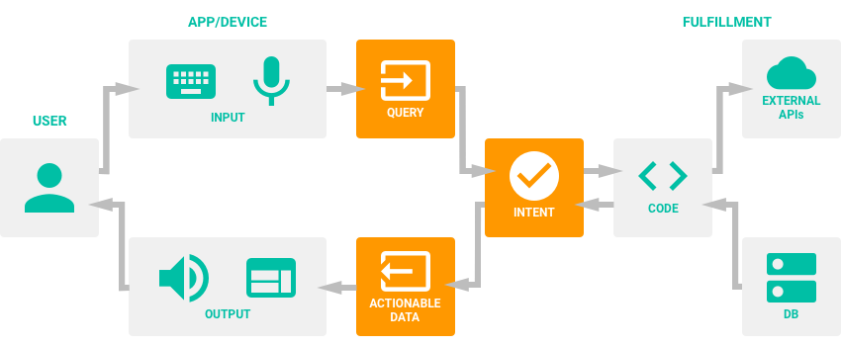

**Architecture Diagram of the Application**

**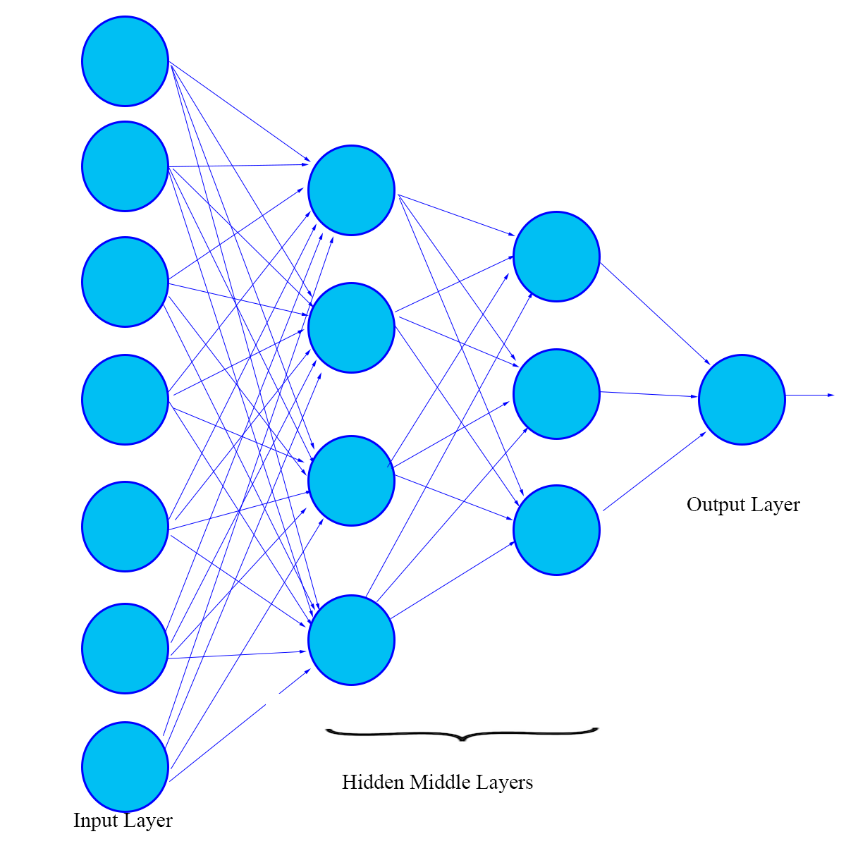**

**Nerual Network of the Chatbot Constructed in TensorFlow**

## Technical Stack

### Platform: Android Application, TensorFlow, Unity, Blender

### System Used: Asus Republic of Gamers GL553VD

### Operating System: Windows 10 Pro (x64 bit)

### IDE Used: Android Studio 2.3.3

### SDK Manager: 25.1.1

### AVD: Moto G4+

### Android Version: 6.0.1 (Marshmallow)

### Cloud Services Used: AWS, Azure QnA Maker

### APIs Used: Google Assistant API

## Services Used:

** ** 

Android TensorFlow  QnA Maker

**   **

AWS S3 AWS CognitoAWS IAMAWS DynamoDB

## Non Functional Coverage

* **TensorFlow**™ is an open source software library for numerical computation using data flow graphs. Nodes in the graph represent mathematical operations, while the graph edges represent the multidimensional data arrays (tensors) communicated between them. The flexible architecture allows you to deploy computation to one or more CPUs or GPUs in a desktop, server, or mobile device with a single API.
* **Unity3D** is a game development software widely used with android applications to bring out more pleasing User Interface Designs.
* **Blender** is the free and open source 3D creation suite. It supports the entirety of the 3D pipeline—modeling, rigging, animation, simulation, rendering, compositing and motion tracking, even video editing and game creation.
* **Amazon S3** has a simple web services interface that you can use to store and retrieve any amount of data, at any time, from anywhere on the web. It gives any developer access to the same highly scalable, reliable, fast, inexpensive data storage infrastructure.
* **Amazon Cognito** lets you add user sign-up/sign-in and access control to your web and mobile apps quickly and easily.
* **AWS Identity and Access Management (IAM)** enables you to securely control access to AWS services and resources for your users. Using IAM, you can create and manage AWS users and groups, and use permissions to allow and deny their access to AWS resources.
* **Amazon DynamoDB** is a fast and flexible NoSQL database service for all applications that need consistent, single-digit millisecond latency at any scale. It is a fully managed cloud database and supports both document and key-value store models. Its flexible data model, reliable performance, and automatic scaling of throughput capacity, makes it a great fit for mobile, web, gaming and many other applications.

## Implementation Architecture

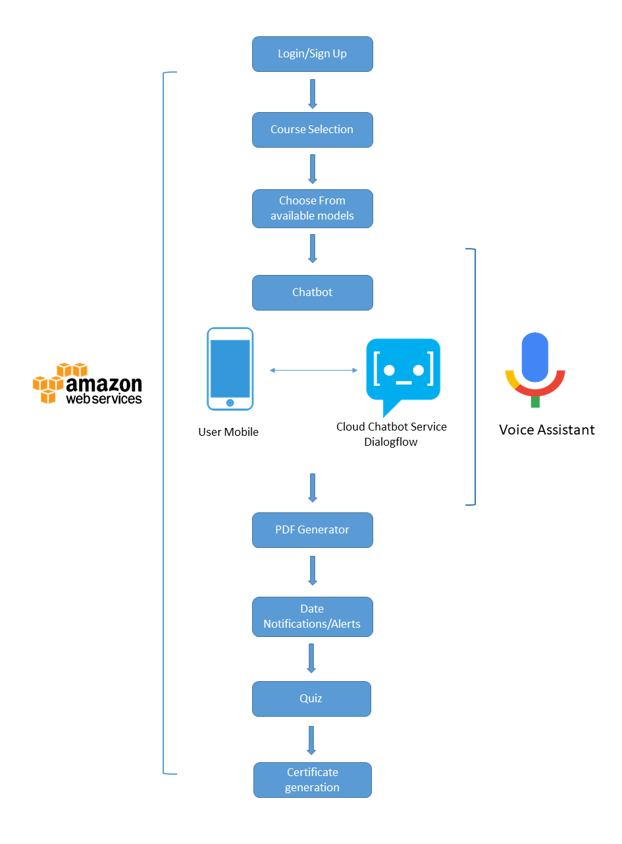

# Delivery Plan

|  |  |  |  |  |
| --- | --- | --- | --- | --- |
| Phase Name | Item description | Deliverable type | Planned Date of Submission | Comments |
| Inititation | Project Planning  Project Design | Simple XML | 19/12/2017 | Completed |
| Coding | Module Coding -1  Module Coding -2  Module Coding -3  Module Coding -4 | Python  Python  C#  Java | 28/12/2017  31/12/2017  05/01/2018  10/01/2018 | Yet To Complete  Yet To Complete  Yet To Complete  Yet To Complete |
| Testing | Beta Testing | .apk | 15/01/2018 | Yet To Complete |
| Product Modifications | Product Refinement | .apk | 20/01/2018 | Yet To Complete |
| Documentation | Final Documentation | .apk | 25/01/2018 | Yet To Complete |

# Appendix – A

TensorFlow  =  <https://www.tensorflow.org/api_docs/>

QnA Maker <https://qnamaker.ai/>

Unity3D     =  [https://unity3d.com/learn/tutorials/topics/tips/documentation-shortcut](https://unity3d.com/learn/tutorials/topics/tips/documentation-shortcut" \t "_blank)

Blender     =  [https://docs.blender.org/manual/en/dev/](https://docs.blender.org/manual/en/dev/" \t "_blank)

Amazon S3   =  [http://docs.aws.amazon.com/AmazonS3/latest/dev/Introduction.html](http://docs.aws.amazon.com/AmazonS3/latest/dev/Introduction.html" \t "_blank)

Amazon Cognito  =  <https://aws.amazon.com/documentation/cognito/>

Amazon DynamoDB =  [https://aws.amazon.com/documentation/dynamodb/](https://aws.amazon.com/documentation/dynamodb/" \t "_blank)

Amazon IAM =  <http://docs.aws.amazon.com/IAM/latest/UserGuide/introduction.html>